What is a QR code?

Well, this is a QR code:
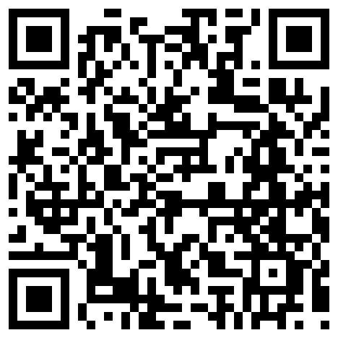

That's what they look like, but what is it?

A two-dimensional barcode.
QR codes store information in two dimensions. The two dimensions allow them to have the capacity for far more information per unit area than regular, one-dimensional barcodes.
These codes are called QR (shortened from Quick Response) because they can be quickly and easily read by smart phones and various dedicated QR readers. QR codes were designed for speedy decoding.

Who comes up with this stuff?
QR codes were created in Japan.
More specifically, the code was made by DENSO Wave, a subsidiary of Toyota in 1994. It's original purpose was to track automobile parts during manufacturing.

How much information can these things store?

It depends on the following:
- Character Set
- Error Correction Level
- Version

The character set refers to what is being encoded.
Just numbers is called numeric; a mix of numbers and letters is alphanumeric. Character sets also include binary and Kanji/Kana (these were made in Japan).

Error correction is just that. If the code gets dirty or damaged, the level of correction corresponds to the amount of code which can be restored. There are 4 levels of error correction; level L restores 7% of code, level M restores 15%, level Q restores 25%, and level H restores 30%.

The versions of QR codes range from 1 to 40. The primary difference of the versions is the number of modules. Modules are the little black and white squares QR codes are made of.
Version 1 QR codes are small, 21 by 21 modules in size. The largest, version 40 QR codes, are 177 by 177 modules. For every increase of version the number of modules on each side increase by 4. So a version 2 is 25 by 25, a version 3 is 29 by 29, and so on.
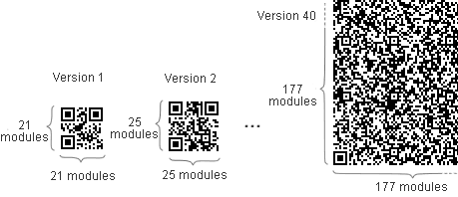

For the largest size of QR code, version 40, and the lowest level of error correction, level L, QR codes can store:
- 7,089 Numeric characters
- 4,296 Alphanumeric characters
- 2,953 bytes of Binary (8 bits)
- 1,817 Kanji characters (with full-width Kana)

The Basic QR Code Structure
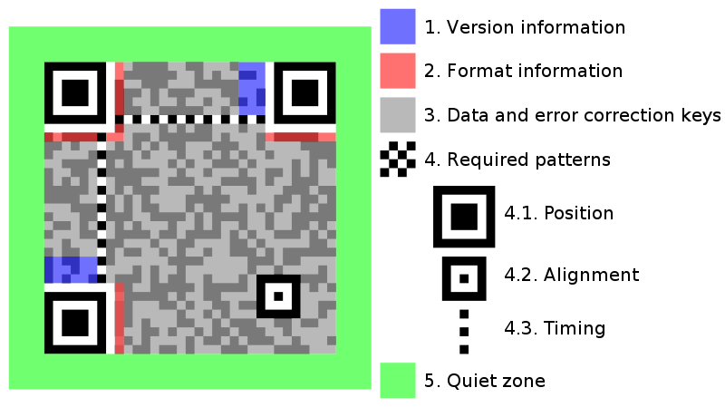
Note: the quiet zone must be at least four modules wide.

What is a QR code?

Submitted by Jessie Daniels
RA, West Virginia University Tech
This bulletin board was done for move in day and residents and their parents found it interesting.

