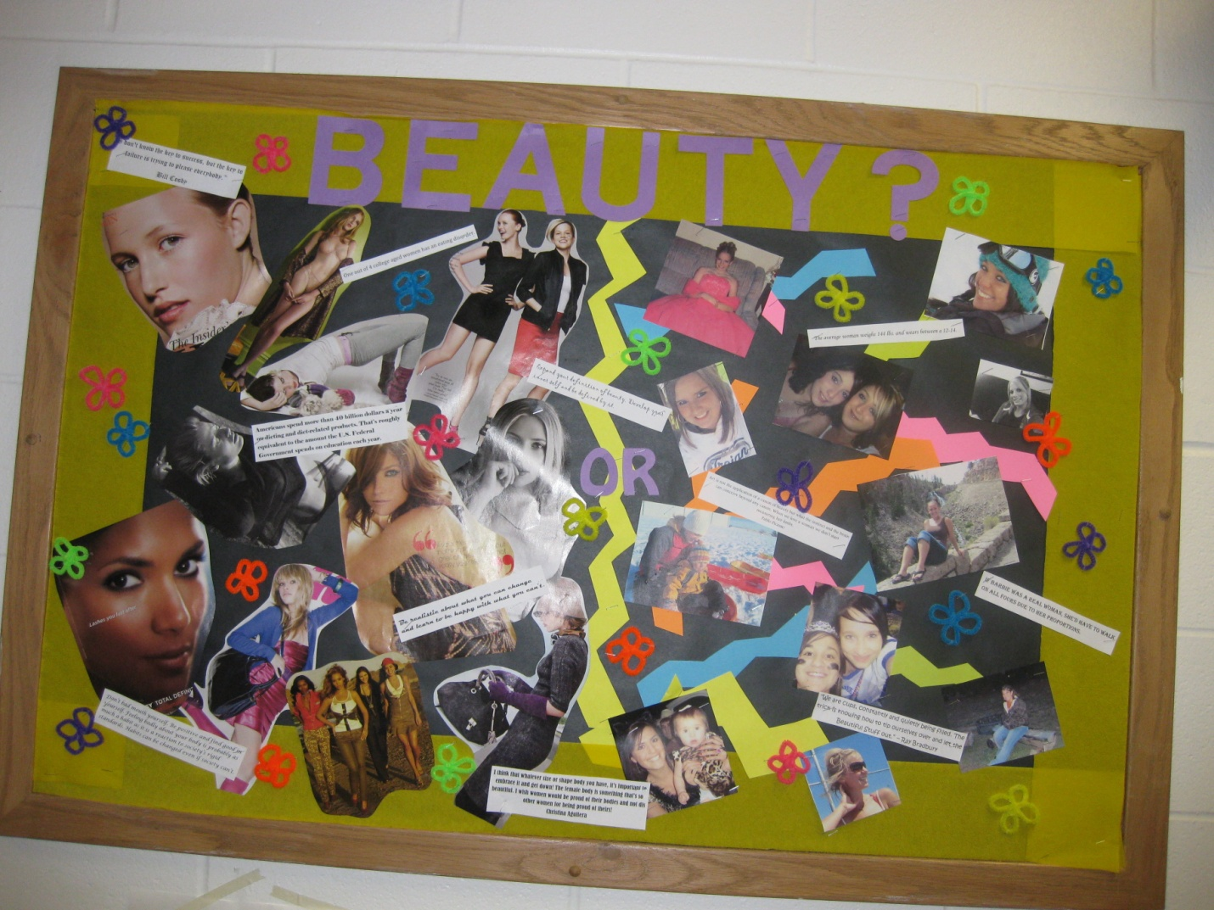

This bulletin board was done in a female wing with all freshman students. I thought it was important for the girls to really question what the true meaning of beauty is. I just tore out some pictures from some magazines that I thought looked like what society thinks beauty is. Then I got some pictures of my residents so they could compare what beauty is thought to be and what beauty really is. I then found some stats and quotes about beauty and put them around the bulletin board.

Submitted by Rebecca Wiedmer, Resident Assistant

