The Ultimate History of Nintendo
Submitted by Brent McBride
Resident Assistant at the University of Maryland, Baltimore County
Source: Kent, Steven L. The Ultimate History of Video Games. New York: Random House International, 2002. Print.

(see picture and text on following slides)

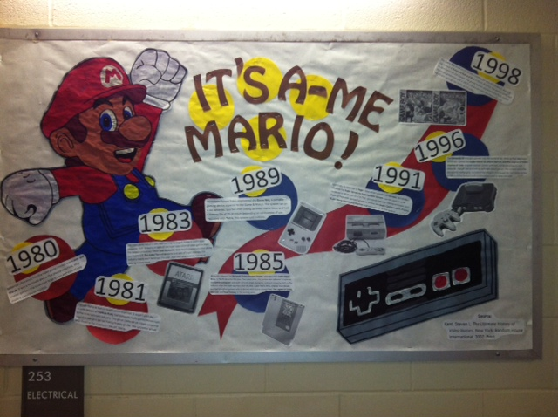
1980
After a semi-successful run as a playing card manufacturer, Nintendo’s first entry into the video game market was Game and Watch. It was a handheld device that played simplistic, stop-motion games – the innovative large screen and ease of play made it a sleeper hit across the world.

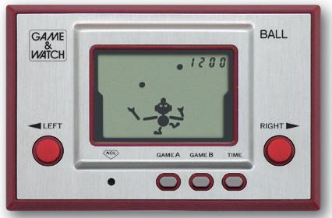

1981
Though Game & Watch caught some attention, it wasn’t until the arcade release of Donkey Kong that Nintendo really gained momentum in the entertainment industry. The game centered on a lowly carpenter bent on rescuing a damsel from a tireless gorilla. This carpenter, initially called “Jumpman”, would later serve as inspiration for the company’s current mascot, Mario.
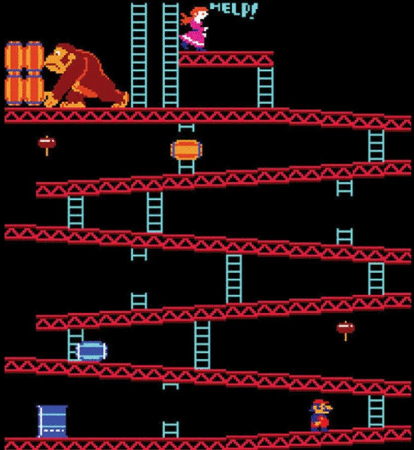

1983
The video game industry was approaching its largest slump in years, with consumer faith dropping in light of the super-saturation of video games from the largest companies – Atari and Nintendo. With Atari’s overproduction of the overhyped E.T. The Extra-Terrestrial game and lack of buyer interest, the industry nearly went bankrupt this year. Atari was sold, and the future of gaming looked bleak.

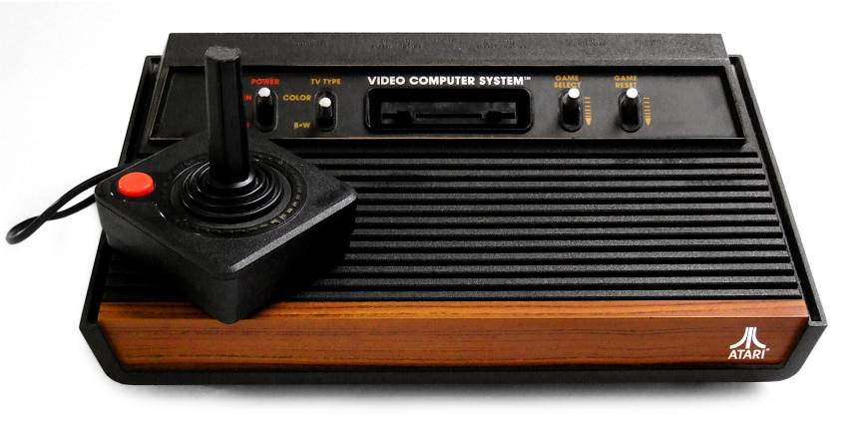

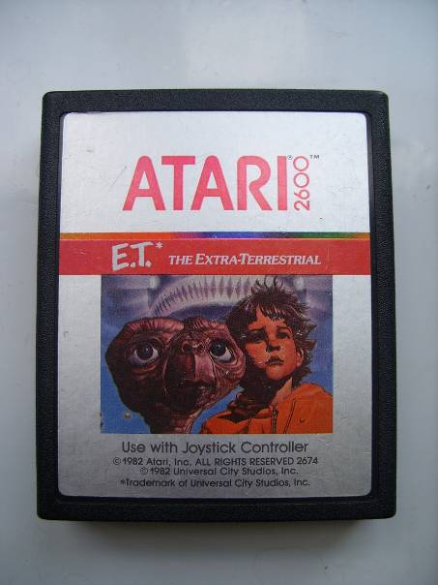
1985
Nintendo released the Nintendo Entertainment System, packaged with Super Mario Bros., in North America this year. Two years prior, this system was released in Japan as the Family Computer, and both versions single-handedly restored consumer faith in the industry after the Atari-spurred crash of 1983. Super Mario Bros.’ original level design and feel energized gamers, and paved the way for future blockbuster titles: The Legend of Zelda, Metroid, and Final Fantasy, in the coming years.
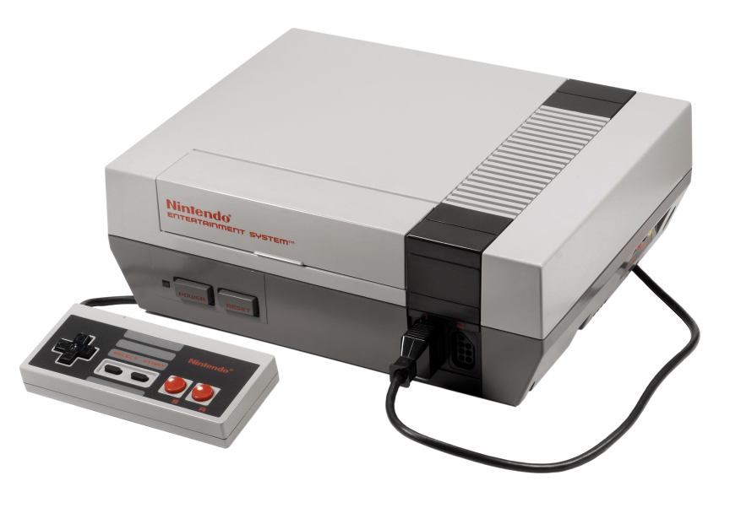
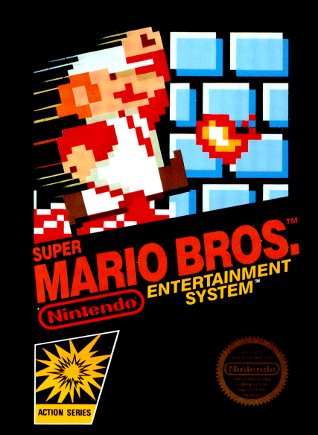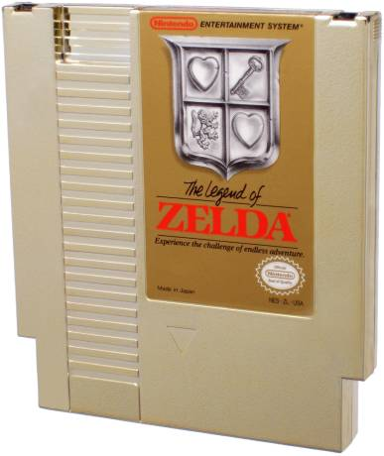
1989
Developer Gunpei Yokoi engineered the Game Boy, a portable gaming device superior to the Game & Watch. The system ran on 4 AA batteries, sported inter-linking between Game Boys, and had a battery life of 10-30 hours dependent on use. Packaged with Tetris, this system pushed handheld gaming into the mainstream.
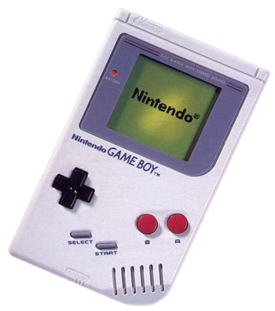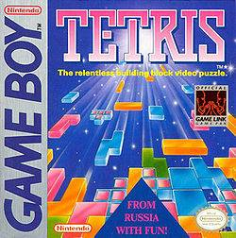

1991
Seemingly in response to Sega’s new 16-bit system, the Genesis, Nintendo released the Super Nintendo Entertainment System. Games could now be rendered in 3D thanks to a FX Chip, and simulate rotational motion and depth of field with updated graphics. Games like Super Castlevania IV, F-Zero, Super Mario World, and StarFox reigned supreme on the system.
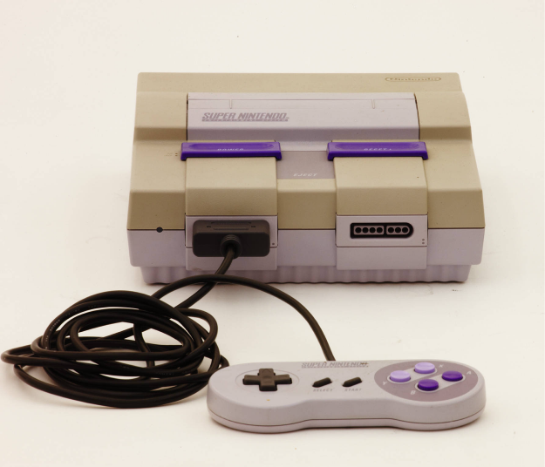

1996
The Nintendo 64 brought gamers into the world of 3D, more so than the Super Nintendo. Games like Super Mario 64, Mario Kart 64, and The Legend of Zelda: Ocarina of Time created realistic worlds with fully rendered polygons and textures. Though still promoting cartridge-based games, the unique controller allowed for better grip, increased handling for driving games, and more variety in terms of the buttons and combinations used to execute tasks.
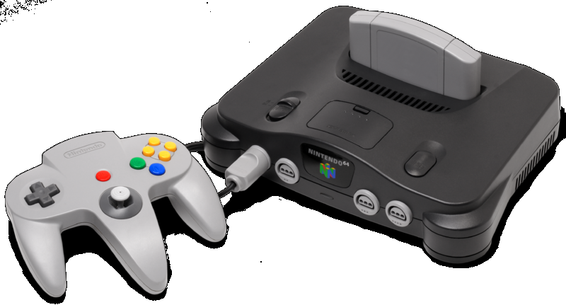
1998
The Game Boy stood economically uncontested since its inception, and with the release of Pokémon Red and Blue in North America, the system became the market. The games sold an unprecedented 9.85 million copies (by production end in 2007) and are among the most culturally significant video games in the world today.

