Alcohol

Submitted by Torey Stockwell
Resident Assistant, Michigan State University
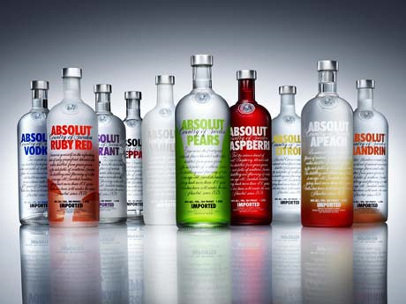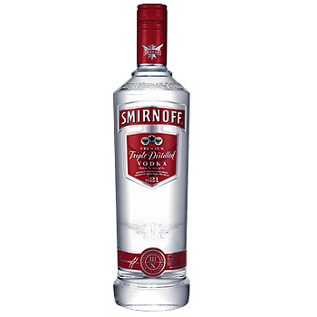

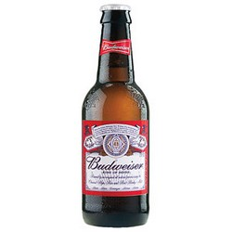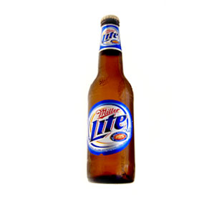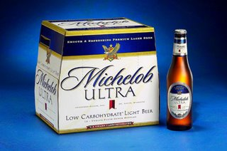
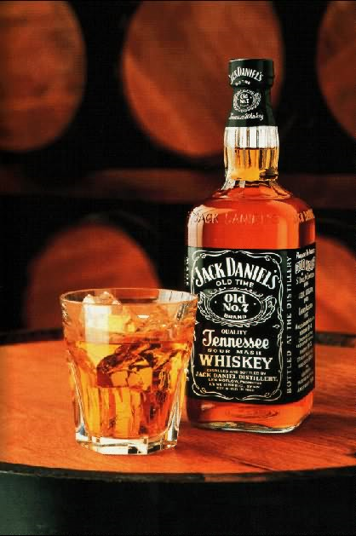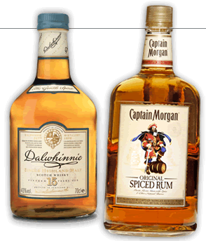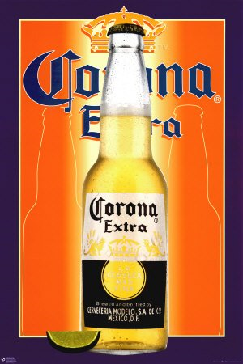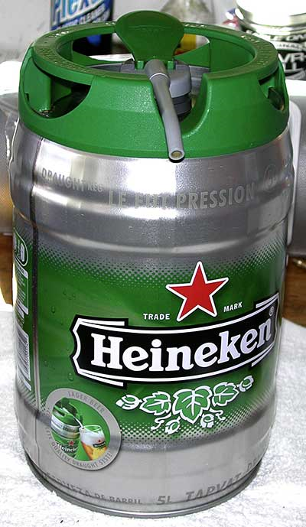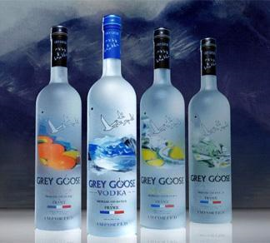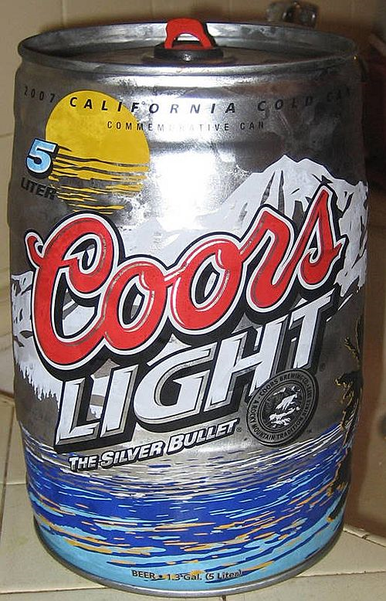

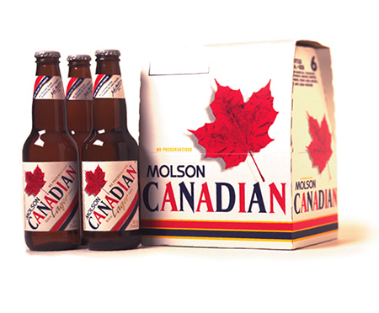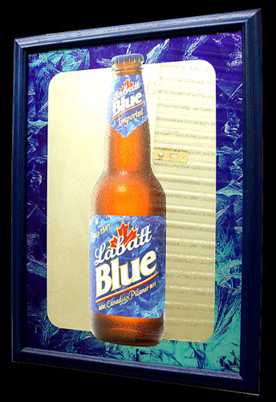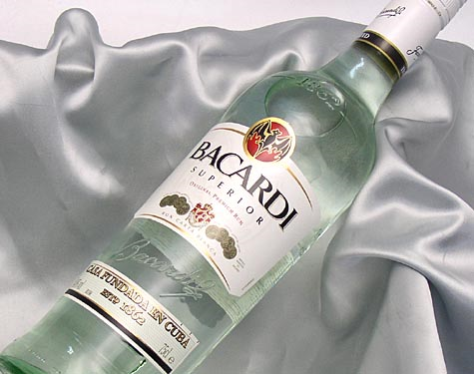
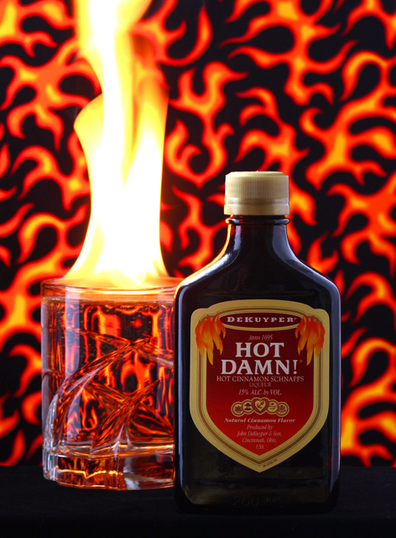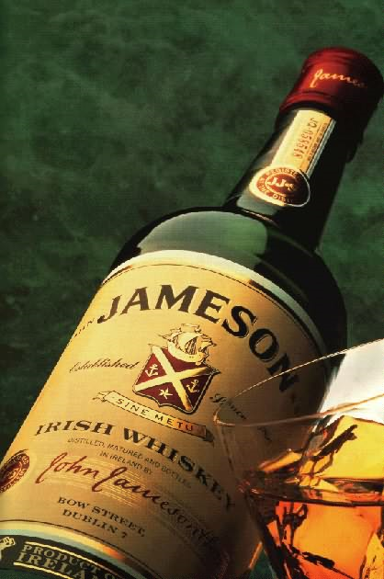
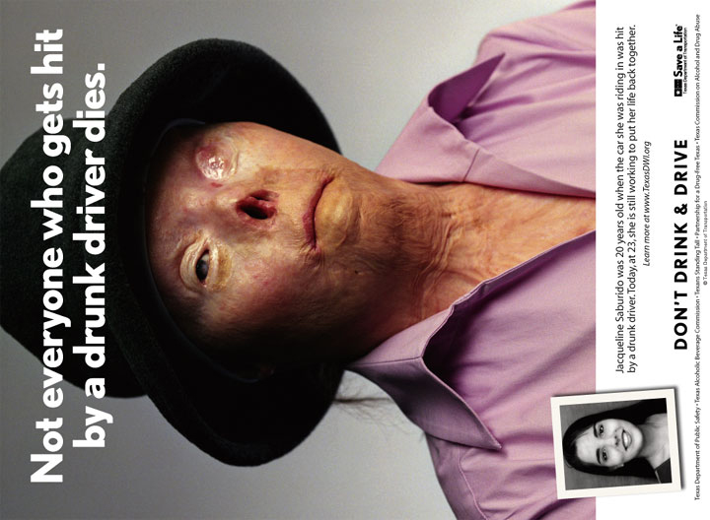
PSA 2002
One LAST Drink…
Alcohol can be dangerous, so be smart and look out for your friends. Make sure they are also making smart choices.

Also, drinking and driving is never EVER a good choice! The choice is yours: You Drink & Drive. You Lose.

It is a violation of state law and of University Policy to consume alcohol if you are under 21.
What do these people have in common?

Jason Kirsinas, 21
Jason Reinhardt, 21
Steve Saucedo
Samantha Spady, 19, of Beatrice, Neb
Lynn Gordon Bailey Jr., 18, of Dallas
Thomas Ryan Hauser, 23
Blake Adam Hammontree, 19
Bradley Barrett Kemp, 20

All of these students, last seen drinking heavily, were found dead.

Don’t let your name be added to this list!!

http://lizditz.typepad.com/i_speak_of_dreams/2004/10/a_problem_.html
May 2004 - California State University-Long Beach student and President's Scholar Jason Kirsinas dies after lapsing into a coma following a night of drinking on his 21st birthday.

March 2004 - Jason Reinhardt, a former student of Minnesota State University-Moorhead, dies of alcohol poisoning on his 21st birthday at the Phi Sigma Kappa house. Reinhardt has 16 drinks between midnight and 1 a.m. at a Moorhead, Minn., bar before going to the fraternity house with friends. His blood-alcohol content was 0.36.

March 2004 - University of California-Berkeley student, Steve Saucedo dies after an off-campus drinking contest with a group of friends.

December 2003 - South Dakota School of Mines and Technology student Tyler Loeb dies of alcohol poisoning from drinking while driving with friends looking for a Christmas tree in the Black Hills. An autopsy shows Loeb had a blood-alcohol content of 0.55 percent.

December 2003 - Pennsylvania York College sophomore Andrew Stephen Hayes dies of alcohol poisoning after attending a party with some members of the Sigma Delta Chi fraternity. His blood-alcohol level was 0.35.

October 2003 - Louisiana State University sophomore Corey James Domingue dies after drinking a bottle of rum in his off-campus apartment. His blood-alcohol content was .43.

October 2003 - North Dakota University of Mary football player Dusten Gailey dies of alcohol poisoning after consuming alcohol at a house party in Bismarck with friends.

September 2003 - Illinois Bradley University student Robert Schmalz dies after 12 hours of drinking at Phi Kappa Tau fraternity celebration for the end of fall pledge. His blood alcohol level was .33.

June 2003 - Friends find the body of University of Idaho student Nick Socorro Cannon in the off-campus apartment he rents for the summer from the Sigma Chi fraternity.

February, 2002 - University of Maryland-College Park freshman Daniel Reardon is found in a lounge at Phi Sigma Kappa house in cardiac arrest caused by excessive alcohol consumption. He dies after removal from life support.

October 2000 - California State University-Chico freshman Adrian Heideman dies from complications of alcohol poisoning after drinking a bottle of brandy at a Pi Kappa Phi fraternity pledge party.

April 2000 - University of California Davis senior David Thornton dies after downing 21 drinks to celebrate his 21st birthday.

November 1999 - Duke student Raheem Bath drinks too much, passes out and inhales his vomit which leads to a fatal bacterial infection in his lungs.

August 1999 - Texas A&M University student Michael Wagener dies of alcohol poisoning after celebrating his 21st birthday. His blood alcohol level was .48.

November 1998 - Michigan State junior Bradley McCue dies of alcohol poisoning after drinking to celebrate his 21st birthday. McCue drank 24 shots in less than two hours. His blood alcohol level was .44 percent.

September 1997 - Massachusetts Institute of Technology sophomore Scott Krueger dies of alcohol poisoning after binge drinking in the Phi Gamma Delta fraternity house where he pledged. His blood-alcohol level was .41.

August 1997 - Sigma Alpha Epsilon pledge Benjamin Wynne, 20, dies of alcohol poisoning at Louisiana State University. His alcohol-blood content was .588, equal to more than two dozen drinks.

February 1997 - Clarkson University freshman Binaya Oja,17, dies of asphyxiation after drinking beer and liquor with other new fraternity pledges until they vomit.

September 1995 - Matthew Garofalo dies after chugging from a bottle of whiskey during a Lambda Chi Alpha fraternity pledge ceremony at the University of Iowa.

October 1990 - Western Illinois University freshman Nicholas Haben dies of alcohol poisoning after being forced to drink "rookie juice" - a concoction of beer, Schnapps, coffee, tuna, eggs, and hot dogs - as part of his initiation into a lacrosse club.

February 1988 - Rutgers University Lambda Chi Alpha fraternity pledge James Callahan dies after being forced to drink "kamikazes," a potent vodka drink.

September 1986 - University of Texas at Austin freshman, Mark Seeberger, dies after drinking up to 20 ounces of rum during a Phi Kappa Psi hazing.

The consequences of excessive and underage drinking affect virtually all college campuses, college communities, and college students, whether they choose to drink or not.
*Death: 1,400 college students between the ages of 18 and 24 die each year from alcohol-related unintentional injuries, including motor vehicle crashes (Hingson et al., 2002).
*Injury: 500,000 students between the ages of 18 and 24 are unintentionally injured under the influence of alcohol (Hingson et al., 2002).
*Assault: More than 600,000 students between the ages of 18 and 24 are assaulted by another student who has been drinking (Hingson et al., 2002).
*Sexual Abuse: More than 70,000 students between the ages of 18 and 24 are victims of alcohol-related sexual assault or date rape (Hingson et al., 2002).
*Unsafe Sex: 400,000 students between the ages of 18 and 24 had unprotected sex and more than 100,000 students between the ages of 18 and 24 report having been too intoxicated to know if they consented to having sex (Hingson et al., 2002).
*Academic Problems: About 25 percent of college students report academic consequences of their drinking including missing class, falling behind, doing poorly on exams or papers, and receiving lower grades overall (Engs et al., 1996; Presley et al., 1996a, 1996b; Wechsler et al., 2002).
*Health Problems/Suicide Attempts: More than 150,000 students develop an alcohol-related health problem (Hingson et al., 2002) and between 1.2 and 1.5 percent of students indicate that they tried to commit suicide within the past year due to drinking or drug use (Presley et al., 1998).
*Drunk Driving: 2.1 million students between the ages of 18 and 24 drove under the influence of alcohol last year (Hingson et al., 2002).
*Vandalism: About 11 percent of college student drinkers report that they have damaged property while under the influence of alcohol (Wechsler et al., 2002).
*Property Damage: More than 25 percent of administrators from schools with relatively low drinking levels and over 50 percent from schools with high drinking levels say their campuses have a "moderate" or "major" problem with alcohol-related property damage (Wechsler et al., 1995).
*Police Involvement: About 5 percent of 4-year college students are involved with the police or campus security as a result of their drinking (Wechsler et al., 2002) and an estimated 110,000 students between the ages of 18 and 24 are arrested for an alcohol-related violation such as public drunkenness or driving under the influence (Hingson et al., 2002).
*Alcohol Abuse and Dependence: 31 percent of college students met criteria for a diagnosis of alcohol abuse and 6 percent for a diagnosis of alcohol dependence in the past 12 months, according to questionnaire-based self-reports about their drinking (Knight et al., 2002).
http://www.collegedrinkingprevention.gov/StatsSummaries/snapshot.aspx

