Myth: Teaching abstinence is old-fashioned, unrealistic, and ineffective.
Fact: Abstinence until marriage is the only way to completely avoid STDs and out-of-wedlock births, and many people today favor teaching abstinence.

A national poll conducted by the University of Chicago found out that 68% of surveyed adults view premarital sex is “always wrong.”
A poll for USA Weekend found that 72% of teens and 78% of adults agree with the pro-abstinence message.
Myth: Abstinence is a very difficult practice for one to avoid STDs and pregnancies and requires many steps and actions.
Fact: Abstinence requires only self-discipline, no medication or pills, and it leads to no health risks.
According to the Bible, human beings contain the capacity to make choices and exhibit self control.
Critics of sex education often state that sex education tends to create the notion that humans cannot exhibit self-control and therefore the use of contraceptives (birth control pills, condoms, etc) is necessary to accommodate the “animal urges” or instincts.
Myth: Teaching safe sex & sex education reduces the number of pregnancies and STD contractions
Fact: Out of wedlock pregnancies, especially among teens, continue the rise even after sex education was first taught in schools.
After Sweden made sex education compulsory in 1954, the gonorrhea rate increased 75% from 1959-64, divorces tripled, marriage rate dropped 66%, 1 out of 3 children were illegitimate by 1976 even though half of all teen pregnancies were aborted.
Japan has a very low teen pregnancy rate despite having no national sex-education programs.
The rate of sexually active teenage girls in the U.S. have risen from 28% (1971) to 41% (1982) despite investing $500 billion into sex education started in 1973.
Myth: Abstinence is an unnatural behavior and cannot be done after a sexual intercourse.
Fact: Abstinence is natural among humans and can be practiced anytime, even after a sexual intercourse.

Myth: If you wait to have sex, you are a prude or you are gay.
Fact: Waiting to have sex just means you’re smart enough to know that the time isn’t right for you.

Myth: Sex is the only way you can show your love for someone.
Fact: There are many nonsexual ways to show your love for someone. Write love poems, plan a special day together, hold hands, kiss, or just say, “I love you.”
Myth: Sex is the most important part of an intimate, committed, loving relationship.
Fact: Sometimes people think they want sex, but what they are really searching for is emotional intimacy. Emotional intimacy is letting another person know your deepest thoughts and fears. Having sex can be a part of emotional intimacy. But sex is not necessary for two people to have real intimacy. In fact, some people use sexual acts to avoid emotional intimacy. Some people are not comfortable talking about their emotions. Often without realizing it, they substitute the good feeling of having sex (physical intimacy) for the good feeling of emotional intimacy. They are letting someone get physically close to them but are guarding their emotions. They are usually afraid that if they reveal themselves—their deepest secrets, their darkest fears—their partner will reject them.
Myth: My boyfriend/girlfriend will break up with me if I choose to be abstinent.
Fact: Some people have said that abstinence makes the heart grow fonder. This is because a relationship between two people who agree to be abstinent can be based more on emotional than physical intimacy, and is therefore built on a stronger, more enduring foundation. If your relationship is so shaky that your partner will leave if you don’t sleep with him or her, having sex with not make it better. Sex can be very complicated and cannot save a failing relationship. It can actually create more tension in an already bad relationship.
Myth: If you stay abstinent for too long, you won’t be able to have kids.
Fact: As long as a man is producing healthy sperm, he can fertilize a female egg. Even men well past middle age, regardless of their sexual history, can father children. As long as a woman is still menstruating, she has the ability to conceive a child, regardless of her sexual history. Only when a woman experiences menopause and her monthly cycle begins to come to an end—usually sometime in her forties or fifties—is she no longer able to conceive.

Myth: If guys don’t “use it,” they’ll “lose it.”
Fact: If a guy decides neither to have sex nor to masturbate, he will not lose the ability to get an erection, have an orgasm, or father a child. Assuming he is in good physical health, his sexual functioning should be perfectly normal whenever he decides to begin having sex.
Myth: If a male does not have an orgasm, his testicles will turn blue, and it could be a serious medical condition.
Fact: If a man does not have an orgasm, his testicles will not turn blue or result in any medical problems. There is a temporary condition popularly referred to as “blue balls.” This is a painful tenderness that affects the testicles if a guy has been sexually aroused for an extended period but has not had an orgasm. It is not a dangerous or harmful condition. The pain will eventually go away. It will be relieved more quickly if the guy masturbates.
Myth: Condoms are 100 percent safe.
Fact: No form of contraception is 100 percent effective against either pregnancy or STDs. When used correctly, condoms are 97 percent effective. And polyurethane condoms are more likely to slip off the penis during withdrawal and also to break than latex condoms
In practice, condoms fail to prevent pregnancy as much as 20% of the time.
Condoms only cover the penis and don't protect you from herpes lesions or genital warts.
Condoms have not been proven to decrease the risk of gonorrhea, syphilis, Hepatitis B or trichomoniasis.

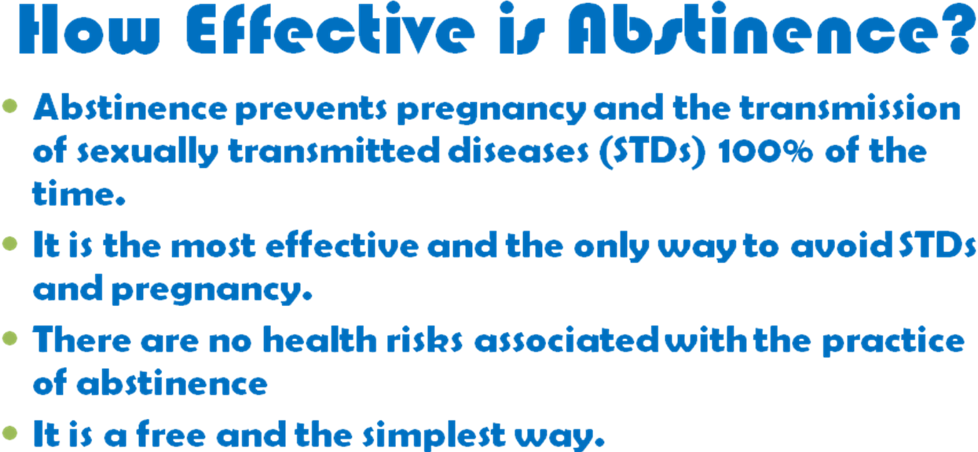

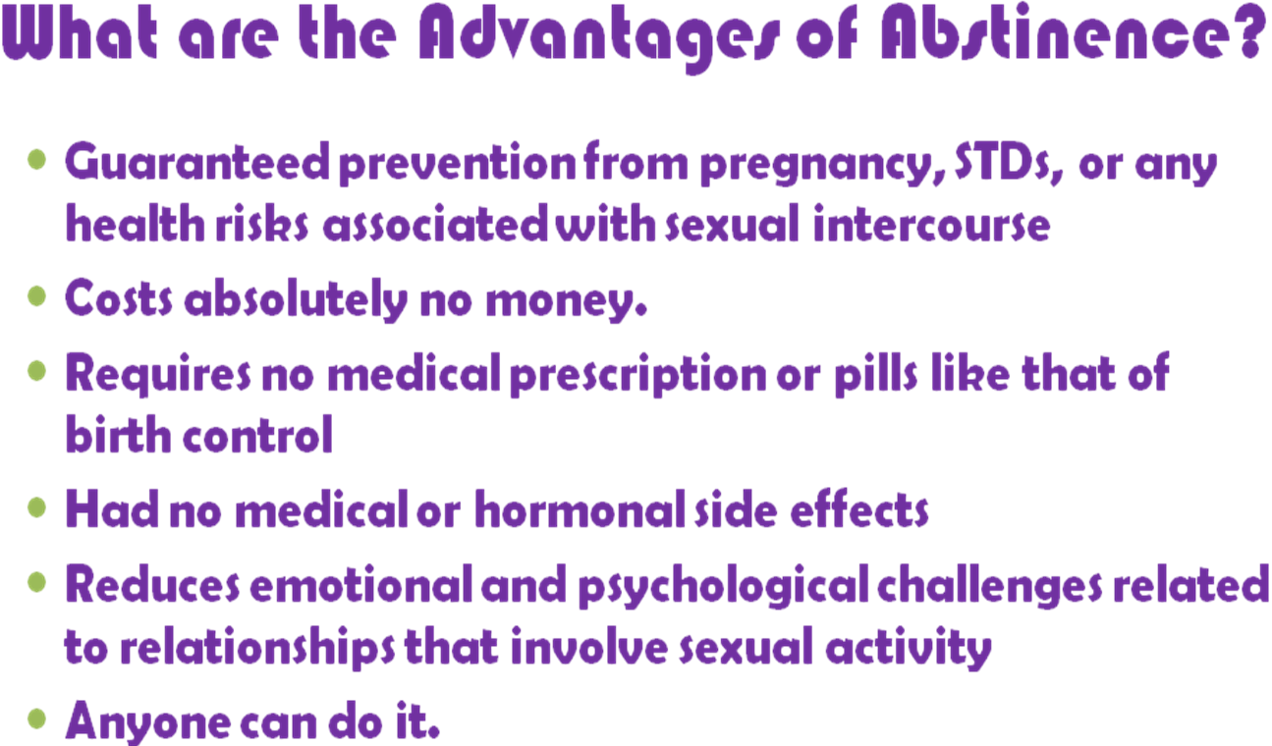

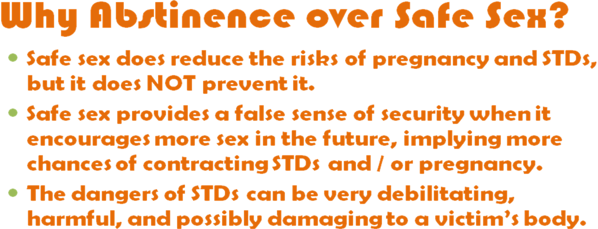

Submitted By:
Anthony Bartens, Resident Advisor
U.H.S., Cal Poly Pomona

