Calorie Consumption for Popular Alcoholic Beverages
Beverage | Calories
Anheuser Busch Natural Light | 95
Anheuser Busch Natural Ice | 157
Bud Light | 110
Budweiser | 145
Busch Beer | 133
Busch Light | 110
Coors Beer | 142
Coors Light | 102
Keystone Light | 104
Miller Lite | 96
Milwaukee's Best | 128
Milwaukee's Best Light | 98
Pabst Blue Ribbon | 153
Corona Extra Beer | 148
Guinness Extra Stout | 153
Heineken Lager Beer | 150
Rum | 125
Scotch Whisky | 115
Southern Comfort | 180
Tequila | 115
Vodka | 125
Whisky | 125
Smirnoff Ice | 228
Bacardi Silver | 225
Skyy Blue | 235
Mike's Hard Lemonade | 220

If you are worried about the “freshman fifteen” you can start by not drinking. Take a look at the calorie intake on some popular alcohol beverages

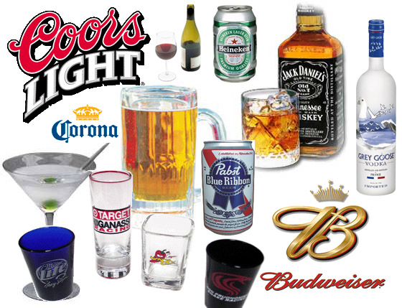
This is not a condemnation of alcohol, or the people who consume it responsibly and are of legal age. It is merely to spread awareness of a problem our nation is facing and to promote responsible and healthy drinking habits.
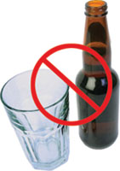
REMEMBER: No alcohol is permitted in the residence halls unless you are 21 years of age.

Refer to the student handbook at _____ if you have any further questions regarding campus alcohol polices.

The content of this pamphlet was compiled by information found at: www.madd.org www.rochester.edu/uhs/healthtopics/Alcohol/caloricvalues.html
Myths, Lies, and Just Plain Stupid “Facts” about Alcohol

College presents individuals with many opportunities to experience new things. Many students take the time to learn about new subject matters, join interesting clubs, play sports, partake in student governments, study abroad, or become an RA, all of which are positive associations with college life. Then there are others who choose another route; a road paved by sex, drugs, and alcohol

This pamphlet will discuss some common myths associated with alcohol. It will also give some startling statistics and some unknown facts pertaining to alcohol and underage drinking.
Ten Myths about Alcohol
- Myth: Alcohol is a great way to relax and reduce stress.
Fact: Alcohol increases the level of stress that is placed on the body. Adrenaline levels increase in the body as we drink. We may feel more relaxed when we drink alcohol, but the body actually comes under additional stress.
- Myth: Alcohol improves sexual performance.
Fact: Although a small amount of alcohol may make you feel less inhibited and may stimulate your interest in sex, anything more will decrease and reduce your ability to perform and numb your sensitivity.
- Myth: There is no point in postponing drinking until I'm over 21.
Fact: Research shows that the longer you postpone drinking, the less likely you are to ever experience alcohol-related problems. Research also shows that the brain does not finish developing until a person is at least in their early 20s, and one of the last regions to mature is intimately involved with the ability to plan and make complex judgments. They made the legal age limit 21 for a reason.
- Myth: Women can “hold” their alcohol as well as a man. .
Fact: Women process alcohol differently. No matter how much a man drinks, if you drink the same amount, you will be more intoxicated and more impaired.
MAKE RESPONSIPLE DECISIONS WHEN IT COMES TO DRINKING →
YOU SHOULD NOT DRINK UNTIL YOU’RE 21

- Myth: Black coffee and a cold shower will sober you up.
Fact: The average person metabolizes alcohol at the rate of about one drink per hour. Only time will sober a person up. Drinking strong coffee, exercising or taking a cold shower will not help.
- Myth: You can drink and still be in control.
Fact: Drinking impairs your judgment, which increases the likelihood that you will do something you'll later regret such as having unprotected sex, being involved in date rape, damaging property, or being victimized by others. This also goes along with believing you can still drive even after you drink. Although you may feel fine, your judgment is impaired and you should never drive under the influence; always have a designated driver or call a taxicab.
- Myth: Beer doesn't have as much alcohol as hard liquor.
Fact: A 12-ounce bottle of beer has the same amount of alcohol as a standard shot of 80-proof liquor (either straight or in a mixed drink) or 5 ounces of wine. Alcohol is alcohol. Your blood alcohol content (BAC - the percent of alcohol in your blood) is what determines how drunk you are. Not the flavors you selected.
- Myth: Drugs are a bigger problem than alcohol.
Fact: Although alcohol use is legal when you are 21, and is more socially acceptable, it is still classified as a drug. Alcohol has claimed the lives of more young people than cocaine, heroin, and every other illegal drug combined. About 18 million Americans are addicted to alcohol or have alcohol abuse issues. Furthermore, alcohol is the No. 1 drug problem of today's youth.

- Myth: Drinking isn't all that dangerous.
Fact: One in three 18-24 year olds admitted to emergency rooms for serious injuries are intoxicated. And alcohol is also associated with homicides, suicides, and drowning. Alcohol is closely linked with violence. About 40 percent of all crimes (violent and non-violent) are committed under the influence of alcohol. In 2004, 30 percent of all fatal crashes during the week were alcohol-related, compared to 51 percent on weekends. For all crashes, the alcohol involvement rate was 5 percent during the week and 12 percent during the weekend. About three in every ten Americans will be involved in an alcohol-related crash at some time in their lives. Just to throw out some other statistics for college aged students:
- 1,400 college students between the ages of 18 -24 die each year from alcohol misuse
- 70,000 college students reported cases of sexual abuse because of alcohol use
- 600,000 reported cases of students being assaulted by someone who had been drinking
- 500,000 college students unintentional injuries blamed on alcohol use
- Myth: Everyone in college drinks!
Fact: Although it may seem like everyone you know is drinking, in reality they are not. It is true that underage drinking is a problem with 54% of freshman illegally consuming alcohol and binge drinking is also becoming a problem, but that still means 46% are not drinking. The number of college students who do not drink is beginning to grow. The percentage of abstainers increased from 15 to 19 percent. 70 % of college age students also favor 21 as the minimum age to sell or serve alcohol. 65 % want the rules more strongly enforced. Just remember that you do not have to drink in order to fit in. There are many alternatives to drinking; you just have to find them!

