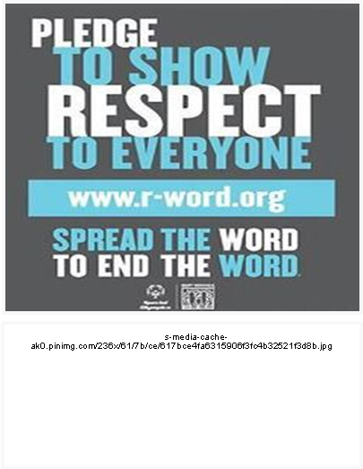  THINK  Many people use hate speech without thinking about it or even realizing what they’re saying. Take time to think about your word choice and make a conscious effort to stop using derogatory / offensive language. |  |  |  | Hate Speech  - Think about how your word choice may be affecting others.  http://dovenews.files.wordpress.com/2013/09/555618_515093211916958_1669489031_n.jpg
“SLUT”
“CUNT”
“FAG”
“WHORE”
“THAT’S SO GAY”
“RETARD”
“KILL YOURSELF"
“DYKE”
“QUEER"
If you have been affected by hate speech, derogatory language, bullying, offensive behavior, etc., please talk to someone.  Resources include but are not limited to:  - The counseling center  - Residential life staff  - The campus clergy |  | 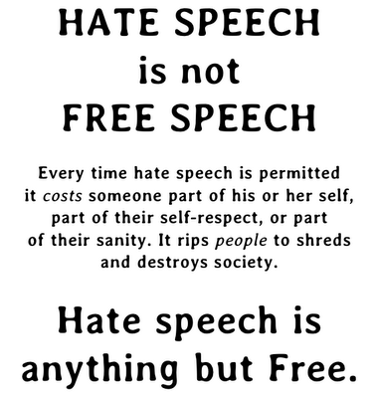  https://whyweprotest.net/attachments/hate-speech-is-not-free-speech-png.208247  Hate Speech is  By the definition in law, hate speech is “any speech, gesture or conduct, writing, or display which is forbidden because it may incite violence or prejudicial action against or by a protected individual or group, or because it disparages or intimidates a protected individual or group.”  Hate speech will not be tolerated on this campus, and especially in my hallway. Take the pledge to stop hate speech and help protect everyone in this community. |  | Hate speech hurts and can ruin lives  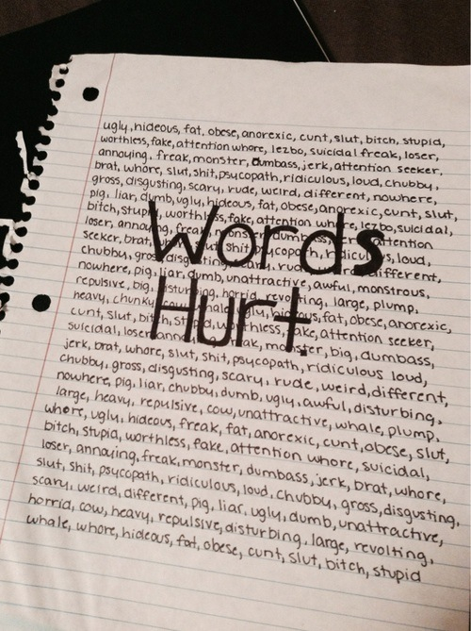  https://40.media.tumblr.com/4cf0cae6714fd0bb7f4c8ab0e0fbd445/tumblr_n4c8v1opTp1soudedo1_500.jpg  How YOU can make a difference  - Make a conscious effort to stop using hate speech  - Speak up when you hear somebody else using hate speech or offensive language  - Speak up if there are specific people using hate speech regularly  - Report those who do not stop after you ask them to
https://40.media.tumblr.com/4cf0cae6714fd0bb7f4c8ab0e0fbd445/tumblr_n4c8v1opTp1soudedo1_500.jpg

