History
Festivus is an annual holiday invented by Reader's Digest writer and Editor Dan O'Keefe. It was introduced to popular culture by O'Keefe's son Daniel, a scriptwriter for the TV show Seinfeld, on December 18, 1997, in the episode "The Strike". (Season 9, Episode 10) The holiday is celebrated each year on December 23, but many people celebrate it at other times, often to avoid the Christmas rush. The holiday includes novel practices such as the "Airing of Grievances", in which each person tells everyone else all the ways they've disappointed him/her over the past year. Also, after the Festivus meal, the "Feats of Strength" are performed, involving wrestling the head of the household to the floor, the holiday only ending if the head of the household is actually pinned.
Some people, influenced or inspired by Seinfeld, now celebrate the holiday, in varying degrees of seriousness; some carefully following rules from the TV show or books, others humorously inventing their own versions.

The Human fund
Money for people

On the show, George donates money in peoples names to, “The Human Fund”, which he made up in order to avoid persecution for not celebrating Christmas. It’s a Festivus tradition to send cards to your loved one with such donations.

The Festivus Pole

During Festivus, an unadorned aluminum pole is displayed. It is preferable to the Christmas tree because it is low maintenance and Frank Costanza finds tinsel distracting.
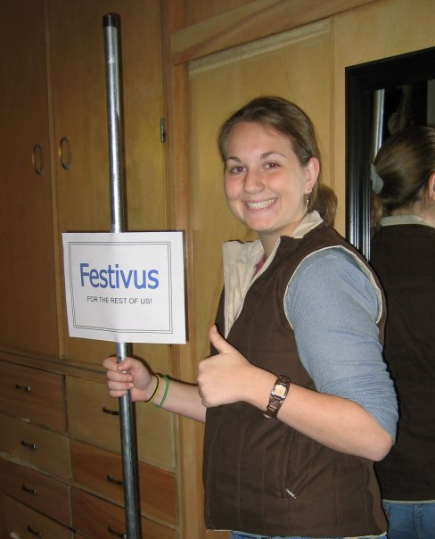

Festivus Dinner

In "The Strike," a celebratory dinner is shown on the evening of Festivus prior to the Feats of Strength and during the Airing of Grievances. The on-air meal appeared to be meat loaf or spaghetti in a red sauce. In Festivus: The Holiday for the Rest of Us by Allen Salkin, drinking is encouraged with hearty beer, rum, bourbon, or wine. In the episode, no alcohol was served, but George Costanza's boss, Mr. Kruger, drank from a flask.

Airing of Grievances

The celebration of Festivus begins with the Airing of Grievances, which takes place immediately after the Festivus dinner has been served. It consists of lashing out at others and the world about how one has been disappointed in the past year.

Feats of Strength

The Feats of Strength is the final tradition observed in the celebration of Festivus. Traditionally, the head of the household selects one person at the Festivus celebration and challenges that person to a wrestling match. The person may decline if they have something else to do, such as pull a double shift at work. Tradition states that Festivus is not over until the head of the household is pinned in a wrestling match. The Feats of Strength are mentioned twice in the episode before it actually occurs. In both instances, no detail was given as to what had actually occurred, but in both instances, George Costanza ran out of the coffee shop in a mad panic, implying he had had bad experiences with the Feats of Strength in the past.

“Many Christmases ago, I went to buy a doll for my son. I reached for the last one they had, but so did another man. As I rained blows upon him, I realized there had to be another way.
The doll was destroyed. But out of that a new holiday was born . . . a Festivus for the rest of us”
-Frank Costanza
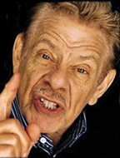

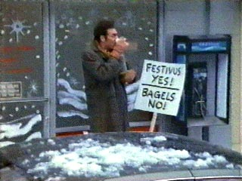
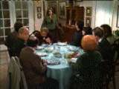

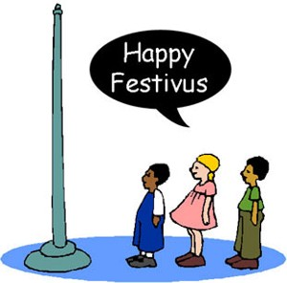

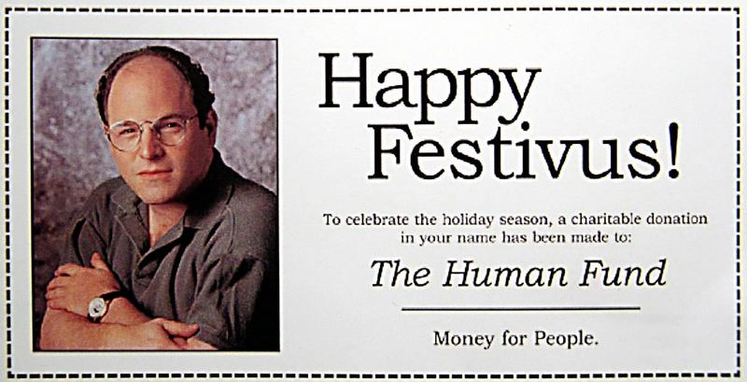

Submitted by Laura Ward,
Resident Assistant,
Colorado State University.


