10 Easy Ways to GO GREEN

Submitted by Laura Ward, Resident Assistant, Colorado State University

- Re-route your commute.


  - Walk or bike to work and save money on gas and parking while improving your cardiovascular health and reducing your risk of obesity.
  - If you live far from your office, investigate the option of telecommuting. Or move closer—even if this means paying more rent, it could save you money in the long term.
  - If your streets are not conducive to biking or walking, lobby your municipal government to increase spending on sidewalks and bike lanes. With little cost, these improvements can pay huge dividends in decreased traffic and pollution.

- Buy used.

  - Whether you’ve just moved to a new area or are looking to redecorate, consider a service like craigslist or FreeSharing to track down furniture, appliances, and other items, rather than buying them new. Check out garage sales and thrift stores for clothing and other everyday items.
  - Use your creativity in gift giving, including making homemade gifts, donating to a good cause, or even regifting. (And gift green, in general.)
  - Your purchasing habits have a real impact, for better or worse. When making new purchases, make sure you know what’s “Good Stuff” and what isn’t.

- Buy local.

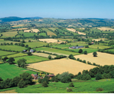
  - Shop at your local farmers’ market. Though the offerings can be more expensive, you can generally count on a higher quality product—and the entire purchase price goes directly to the farmer. Buying any goods produced locally saves energy by reducing the fossil fuels needed to transport food and other items across the country and around the globe.
  - Start a local currency program in your town. This can ensure that money stays in your local economy, valuing local services and supporting local merchants.

- Compost your food scraps.

  - Composting helps reduce the amount of waste you send to the landfill, which can save you money if you live in a municipality with a “pay as you throw” system. In the process, you create free, healthy fertilizer for your garden (or your neighbor’s—or lobby for a community garden!)
  - If you don’t have a yard or space for a compost pile, try indoor ‘vermiculture,’ or worm composting.

- Change the thermostat setting and install energy saving devices.

  - Setting your thermostat a few degrees lower in the winter and a few degrees higher in the summer can translate to substantial savings on your utility bills.
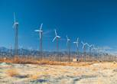
  - Install low-flow showerheads and take shorter showers to save water and the energy used to heat it. Or, consider eventually installing a solar hot water heater on your property.
  - Wash clothes in cold water whenever possible and use a drying rack or clothesline.
  - When incandescent bulbs burn out, replace them with longer-lasting, low-energy compact fluorescent bulbs.
  - With the money you save from making these changes, consider buying wind energy from your local utility or purchasing renewable energy offsets. Renewables offer our best hope for reducing greenhouse gas emissions, as well as a host of other pollutants. In some cases, “green energy” options can be cheaper than electricity from conventional sources!

- Skip the bottled water at the grocery or convenience store.

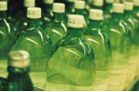
  - Filter your tap water for drinking rather than using bottled water. Not only is bottled water expensive, but it produces large amounts of container waste.

- Make your own cleaning supplies.

  - Using simple ingredients such as baking soda, soap, and vinegar, you can make cheap, easy, and non-toxic cleaning products that really work! Save money, time, and your indoor air quality.

- Think twice about new electronics.

  - E-waste from discarded cell phones and computers is a growing environmental problem. Mounds of electronic refuse are being shipped abroad illegally for ‘disassembly’ by workers with little protection against the mercury and other toxic substances they contain.

  - Keep your electronics as long as possible and dispose of them responsibly when the time comes.
  - Buy higher-quality items and don’t give in to ‘psychological obsolescence’ marketing campaigns.
  - Recycle your cell phone and support good causes at the same time!
  - Ask your local government to set up a responsible recycling and hazardous waste collection event.

- Add one meatless meal per week.

  - While strict vegetarianism isn’t for everyone, even the most devout carnivores can cut back on meat consumption without cramping their style—and save money in the process. Industrial meat production requires huge energy inputs and creates noxious waste problems. The proliferation of factory farms is damaging the environment, and the global nature of the industry creates conditions that promote the spread of diseases such as avian flu, potentially costing society billions.

- Use your local library and other public amenities.

  - Borrowing from libraries, instead of buying personal books and movies, saves money and printing resources. Consider donating the money saved to your local library.
  - Be an active civic participant and ensure that the public spaces and facilities in your town are well maintained. This will promote a healthy, sustainable community.

www.worldwideinsitute.org

When humans burn fossil fuels, sulfur dioxide (SO₂) and nitrogen oxides (NOx) are released into the atmosphere. These chemical gases react with water, oxygen, and other substances to form mild solutions of sulfuric and nitric acid. Winds may spread these acidic solutions across the atmosphere and over hundreds of miles. When acid rain reaches Earth, it flows across the surface in runoff water, enters water systems, and sinks into the soil.

Nationalgeographic.com
Deforestation is clearing Earth's forests on a massive scale, often resulting in damage to the quality of the land. Forests still cover about 30 percent of the world’s land area, but swaths the size of Panama are lost each and every year.
The world’s rain forests could completely vanish in a hundred years at the current rate of deforestation.
Forests are cut down for many reasons, but most of them are related to money or to people’s need to provide for their families. The biggest driver of deforestation is agriculture. Farmers cut forests to provide more room for planting crops or grazing livestock. Often many small farmers will each clear a few acres to feed their families by cutting down trees and burning them in a process known as “slash and burn” agriculture.
Nationalgeographic.com

The ozone layer is a belt of naturally occurring ozone gas that sits 9.3 to 18.6 miles (15 to 30 kilometers) above Earth and serves as a shield from the harmful ultraviolet B radiation emitted by the sun.
Ozone is a highly reactive molecule that contains three oxygen atoms. It is constantly being formed and broken down in the high atmosphere, 6.2 to 31 miles (10 to 50 kilometers) above Earth, in the region called the stratosphere.
Today, there is widespread concern that the ozone layer is deteriorating due to the release of pollution containing the chemicals chlorine and bromine. Such deterioration allows large amounts of ultraviolet B rays to reach Earth, which can cause skin cancer and cataracts in humans and harm animals as well.
Nationalgeographic.com

Carbon dioxide, a greenhouse gas, is the main pollutant that is warming Earth. Though living things emit carbon dioxide when they breathe, carbon dioxide is widely considered to be a pollutant when associated with cars, planes, power plants, and other human activities that involve the burning of fossil fuels such as gasoline and natural gas. In the past 150 years, such activities have pumped enough carbon dioxide into the atmosphere to raise its levels higher than they have been for hundreds of thousands of years.
Other greenhouse gases include methane—which comes from such sources as swamps and gas emitted by livestock—and chlorofluorocarbons (CFCs), which were used in refrigerants and aerosol propellants until they were banned because of their deteriorating effect on Earth's ozone layer.
Nationalgeographic.com

Hazardous wastes are poisonous byproducts of manufacturing, farming, city septic systems, construction, automotive garages, laboratories, hospitals, and other industries. The waste may be liquid, solid, or sludge and contain chemicals, heavy metals, radiation, dangerous pathogens, or other toxins. Even households generate hazardous waste from items such as batteries, used computer equipment, and leftover paints or pesticides.
The waste can harm humans, animals, and plants if they encounter these toxins buried in the ground, in stream runoff, in groundwater that supplies drinking water, or in floodwaters, as happened after Hurricane Katrina. Some toxins, such as mercury, persist in the environment and accumulate. Humans or animals often absorb them when they eat fish.
The rules surrounding hazardous waste are overseen in the U.S. by the Federal Environmental Protection Agency (EPA) as well as state departments of environmental protection. EPA requires that hazardous waste be handled with special precautions and be disposed of in designated facilities located throughout the United States, which charge for their services. Many towns have special collection days for household hazardous waste.
Nationalgeographic.com

The effect of acid rain on our forests
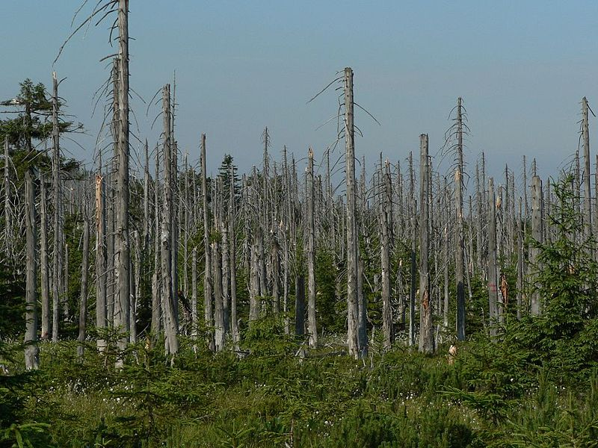

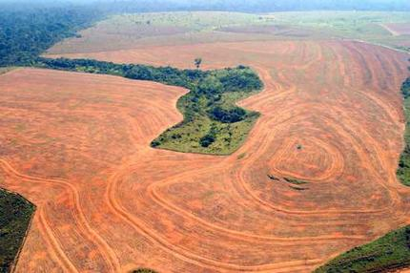

Deforestation in the Amazon
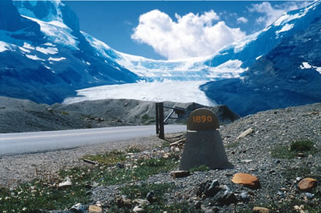
Athabasca Glacier, Canadian Rockies, was near the sign in 1890 and has since melted back to its current location due to global warming.
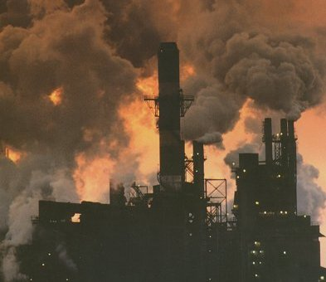
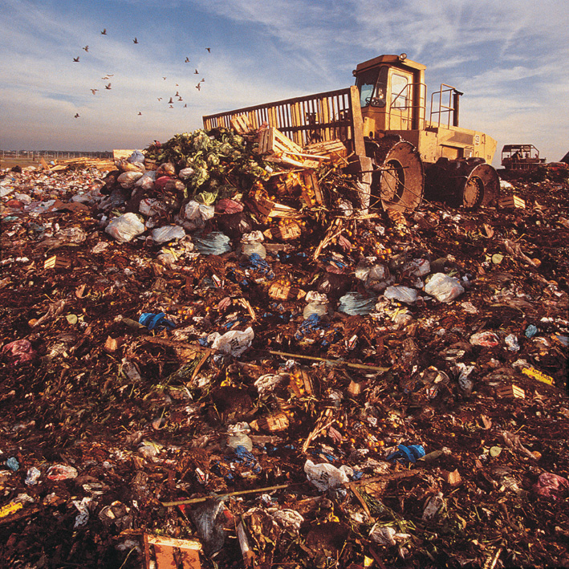

Everything you throw away, goes here.

